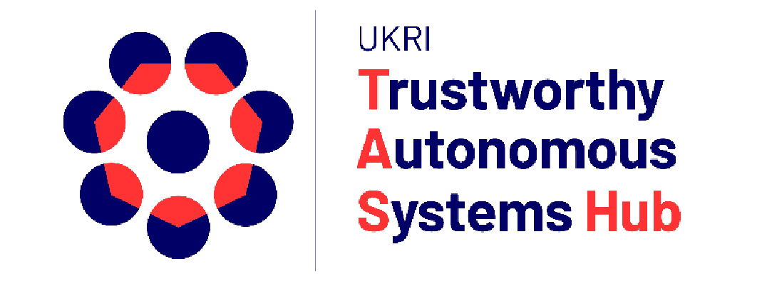
1st Workshop on Methods,
Tools and Techniques for
Trustworthy Autonomous
Systems (TAS) Design and Development
In conjunction with the 14th ACM SIGCHI Symposium on Engineering Interactive Computing Systems (EICS 2022 - 21-24 June 2022 - Sophia Antipolis, France)

WORKSHOP AIMS AND GOALS
This workshop focuses on methods, tools and techniques to design and develop Trustworthy Autonomous Systems (TAS). TAS is an emerging area of interactive systems that is expanding the scope and remit of engineering. At every scale, making autonomous systems trustworthy is a collective task that requires a multidisciplinary team to work together to understand trust design requirements and provide effective and creative solutions. TAS introduce unique challenges in the design and development of interactive systems because they may have the capacity to learn and evolve, they may need to make decisions or take actions independently with little or no human oversight, and they will be deployed in very different cultural and regulatory environments. TAS engineers need robust design methods, tools and techniques to meet diverse TAS requirements and objectives. Our prior research argued for TAS engineers to develop skills in three core areas: soft, strategic and technical. However, little has been done to flesh out the specific methods, tools and techniques that TAS engineers should draw on.
This workshop intends to invite interactive systems experts to contribute promising design methods, tools and techniques – particularly in the area of user/actor and design requirements modelling. The workshop aims to present cutting-edge modelling techniques, and to test these approaches through discussion, to think about main challenges, refine TAS required skills and steer the overarching strategy in this new field for the future.
Our goal is to foster a lively discussion and carry out interactive activities to test, compare and evaluate emergent or established methods, tools and techniques in the area of requirements modelling for TAS.
This documents present our accepted abstracts during the workshop,

Generating user-centered design requirements using the Trust Schema-World-Action Research Method (T-SWARM)

Katie Parnell and Katherine Plant,
University of Southampton

This workshop will present the development and application of the Trust Schema World Action Research Method (T-SWARM) within the Trustworthy Autonomous Systems (TAS) program. Based upon robust and validated theory, the method strives to capture the interaction between trust as experienced within the cognitive processing of an individual, their interactions with the world around them and the information that they require. The workshops will present the origins of the method before showing how it has been developed across TAS projects, with data and outputs from our work to date. Examples will include generating trust requirements for autonomous drone swarm operators as well as understanding trust within the context of health care with a robot-assisted A&E triage. The workshop will present how these requirements were generated, giving specific attention to their holistic nature. It will also discuss lessons learnt and best-practice for applying the method to enable attendees to apply and benefit from the model within their own work.

A proposed safety framework for human-machine teaming

Zena Assaad,
The Australian National University

Autonomous systems are becoming more prevalent across a diversity of industries and applications. The development and deployment of these systems is surpassing the promulgation of standards and regulations needed to govern the safety of these systems. As the potential applications of autonomous systems continue to broaden, segregating these systems from humans will become increasingly difficult and potentially not feasible in some contexts, such as human-machine teaming. Human-machine teaming describes a nuanced and intricate relationship between human and machine as they work together in pursuit of a common goal.
A safety framework for human-machine teaming is proposed. The user centric framework would enable the safe operation of humans alongside machines in a teaming environment in which the machine will not be physically segregated from the human. The framework will provide assurance of both entities, and in addition to addressing physical safety, the framework will also include psychosocial considerations such as trust. The framework will address how a system or capability operates in a specific environment and, more importantly, how humans operate alongside these capabilities. The framework will act as a guiding set of processes for users to follow to ensure the safe operation of humans alongside machines in a teaming environment.

The RCRAFT Framework as a Mean to Structure Requirements for Trustable Automation

Philippe Palanque, and Célia Martinie
ICS-IRIT, University Toulouse

Automation is widespread in interactive applications, promising multiple benefits to users, including enhancing comfort, safety, security, engagement, trust and even well-being. Implicitly or explicitly, automation is now a critical design option for interactive application designers. Unfortunately, despite its long use (especially in safety-critical systems) assessing the benefits and the drawbacks of design alternatives including automation remains a craft activity, unsupported by conceptual frameworks or tools. Requirements addressing automation might be unstructured, unprecise and even conflicting with each other (especially when considering subjective properties such as trust or engagement). In this position paper we present how the RCRAFT framework can be used to identify requirements for trustable automation. The framework considers five attributes of automation: Resources, Control Transitions, Responsibility, Authority, system Functions and user Tasks. The framework targets at user/operator-centered requirements but provides also information in terms of interactions between the operator and the automation. We show how these attributes support the identification of user-centered requirements. This is achieved by integrating the RCRAFT concepts into task models which in-turn may contribute to properties such as transparency, congruence and controllability in addition to usability and User Experience.

